Posterior View of the Body

Muscles Labeling Activity

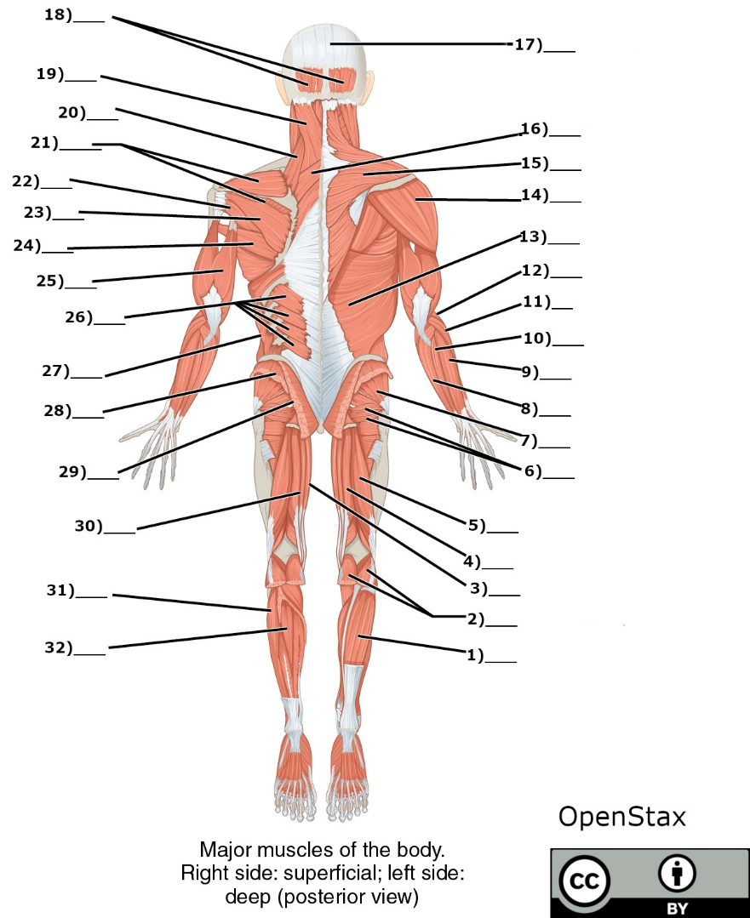

Word Bank

1. Triceps brachii
2. Gluteus minimus
3. Extensor carpi radialis
4. Semimembranosus
5. Gastrocnemius (dissected)
6. Extensor carpi ulnaris
7. Semitendinosus
8. External oblique
9. Gracilis
10. Serratus posterior inferior
11. Splenius Capitis
12. Peroneus longus
13. Biceps femoris
14. Brachioradialis
15. Occipitofrontalis (Occipital Belly)
16. Extensor digitorium
17. Deltoid
18. Rhomboids
19. Supraspinatus
20. Latissimus dorsi
21. Levator scapulae
22. Trapezius
23. Soleus
24. Epicranial aponeurosis
25. Teres minor
26. Gluteus maximus (dissected)
27. Tibialis posterior
28. Gluteus medius (dissected)
29. Flexor carpi ulnaris
30. Gemellus muscles
31. Teres Major
32. Infraspinatus

Answer Key

1. Soleus
2. Gastrocnemius
3. Gracilis
4. Semitendinosus
5. Biceps femoris
6. Gemellus muscles
7. Gluteus minimus
8. Flexor carpi ulnaris
9. Extensor carpi ulnaris
10. Extensor digitorium
11. Extensor carpi radialis
12. Brachioradialis
13. Latissimus dorsi
14. Deltoid
15. Trapezius
16. Rhomboids
17. Epicranial aponeurosis
18. Occipitofrontalis (Occipital Belly)
19. Splenius Capitis
20. Levator Scapulae
21. Supraspinatus
22. Teres minor
23. Infraspinatus
24. Teres major
25. Triceps brachii
26. Serratus posterior inferior
27. External Oblique
28. Gluteus medius (dissected)
29. Gluteus maximus (dissected)
30. Semimembranosus
31. Peroneus longus
32. Tibialis posterior